Unicorn Companies — Descriptive Analysis Report
Cornell Capstone Project • Dataset: Unicorn_Companies.csv (n = 1,074) • Coverage through 2022-04-05
This report describes the population of existing unicorn companies (private, venture-backed startups valued at ≥ $1B). Section A presents the guided descriptive analysis; Section B presents an independent, data-driven insight scan; Section C notes implications for modeling. Every chart and table is followed by a "What this means" note stating the takeaway, so the focus is on what the data implies rather than merely what was computed. All per-category shares describe this dataset’s composition, not real-world probabilities.

Data Preparation
- Industry capitalization inconsistency merged (Artificial Intelligence × 11 + Artificial intelligence × 73 → 84 companies, 7.8%).
- Valuation and Funding parsed from strings (e.g. "$180B") into numeric USD.
- Date Joined parsed to datetime; derived Year Joined and Years-to-Unicorn.

Section A — Guided Descriptive Analysis
This section follows the analytical questions defined by the team: where unicorns are located, what industries they occupy, how they are valued and funded, and how their industry mix has shifted across technological eras.

A1. Geographic Distribution
Continent | Unicorns | Share
North America | 589 | 54.8%
Asia | 310 | 28.9%
Europe | 143 | 13.3%
South America | 21 | 2.0%
Oceania | 8 | 0.7%
Africa | 3 | 0.3%
Top countries: United States (562), China (173), India (65), United Kingdom (43), Germany (26). The US, China, and India together account for 74.5% of all unicorns.
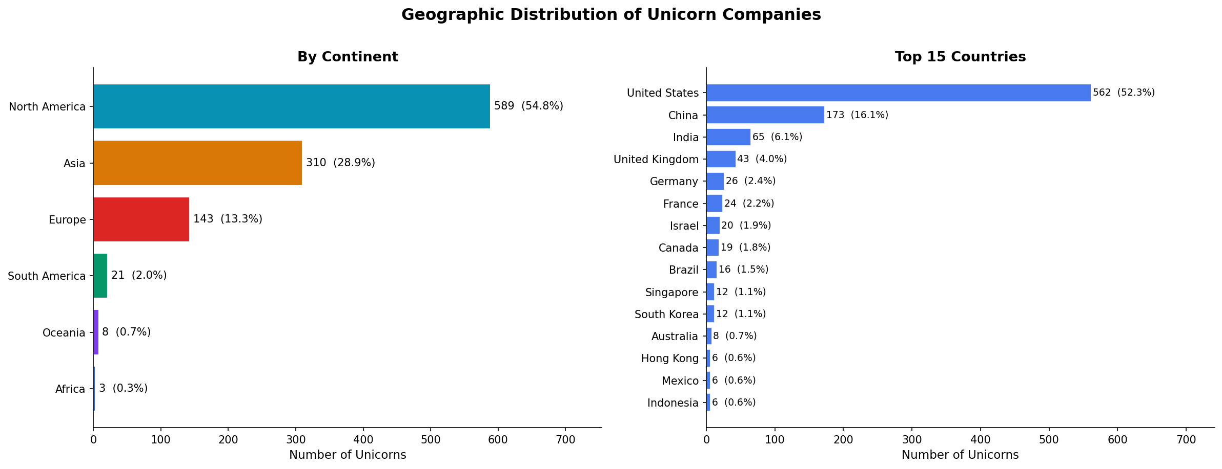
What this means — Unicorn creation is highly concentrated, not globally spread. Three countries produce three-quarters of all unicorns, which tells us that breakout outcomes depend less on market size and more on the maturity of the surrounding ecosystem — deep venture capital, technical talent, and viable exit markets. For a prediction task, a company’s location is therefore a meaningful signal, not just a label.

A2. Industry Distribution
Industry | Unicorns | Share
Fintech | 224 | 20.9%
Internet software & services | 205 | 19.1%
E-commerce & direct-to-consumer | 111 | 10.3%
Artificial intelligence | 84 | 7.8%
Health | 74 | 6.9%
Other | 58 | 5.4%
Supply chain, logistics, & delivery | 57 | 5.3%
Cybersecurity | 50 | 4.7%
Fintech (20.9%) and Internet Software & Services (19.1%) together make up ~40% of all unicorns.
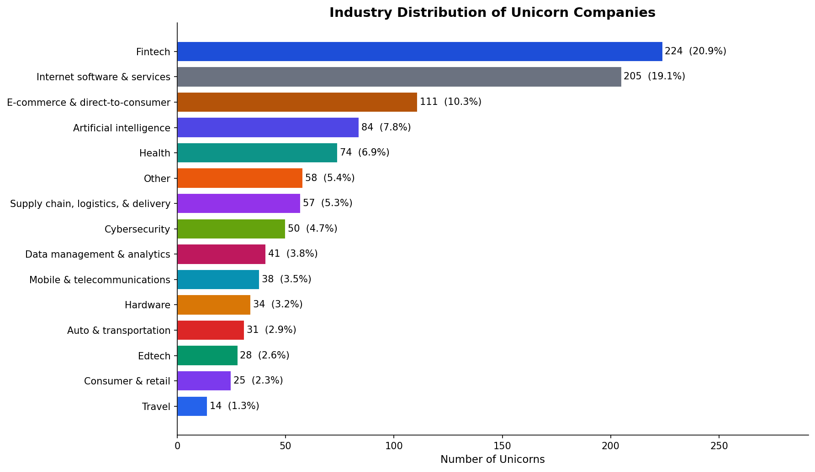
What this means — Value creation clusters in software-driven, digitally scalable business models. The two leading categories — Fintech and Internet Software — are both built on code that scales at near-zero marginal cost, which is exactly what lets a company reach a billion-dollar valuation quickly. Capital-intensive, physical-asset sectors sit far down the list. The takeaway: industry is one of the strongest descriptors of where unicorns come from.

A3. Valuation & Funding
- Median valuation $2B; 94.3% sit in the $1B–$10B range; ByteDance is the extreme top at $180B.
- Median total funding $370M; 65.4% raised under $500M.
- Valuation-to-funding ratio is roughly 5:1, reflecting investor growth premiums.
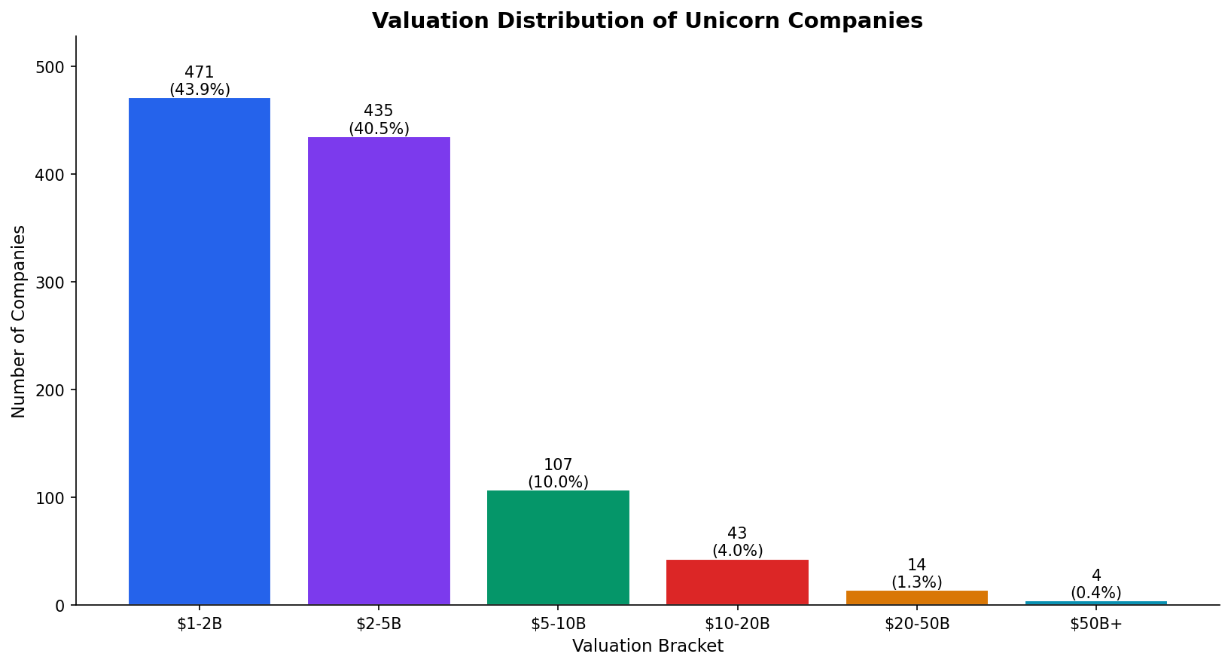
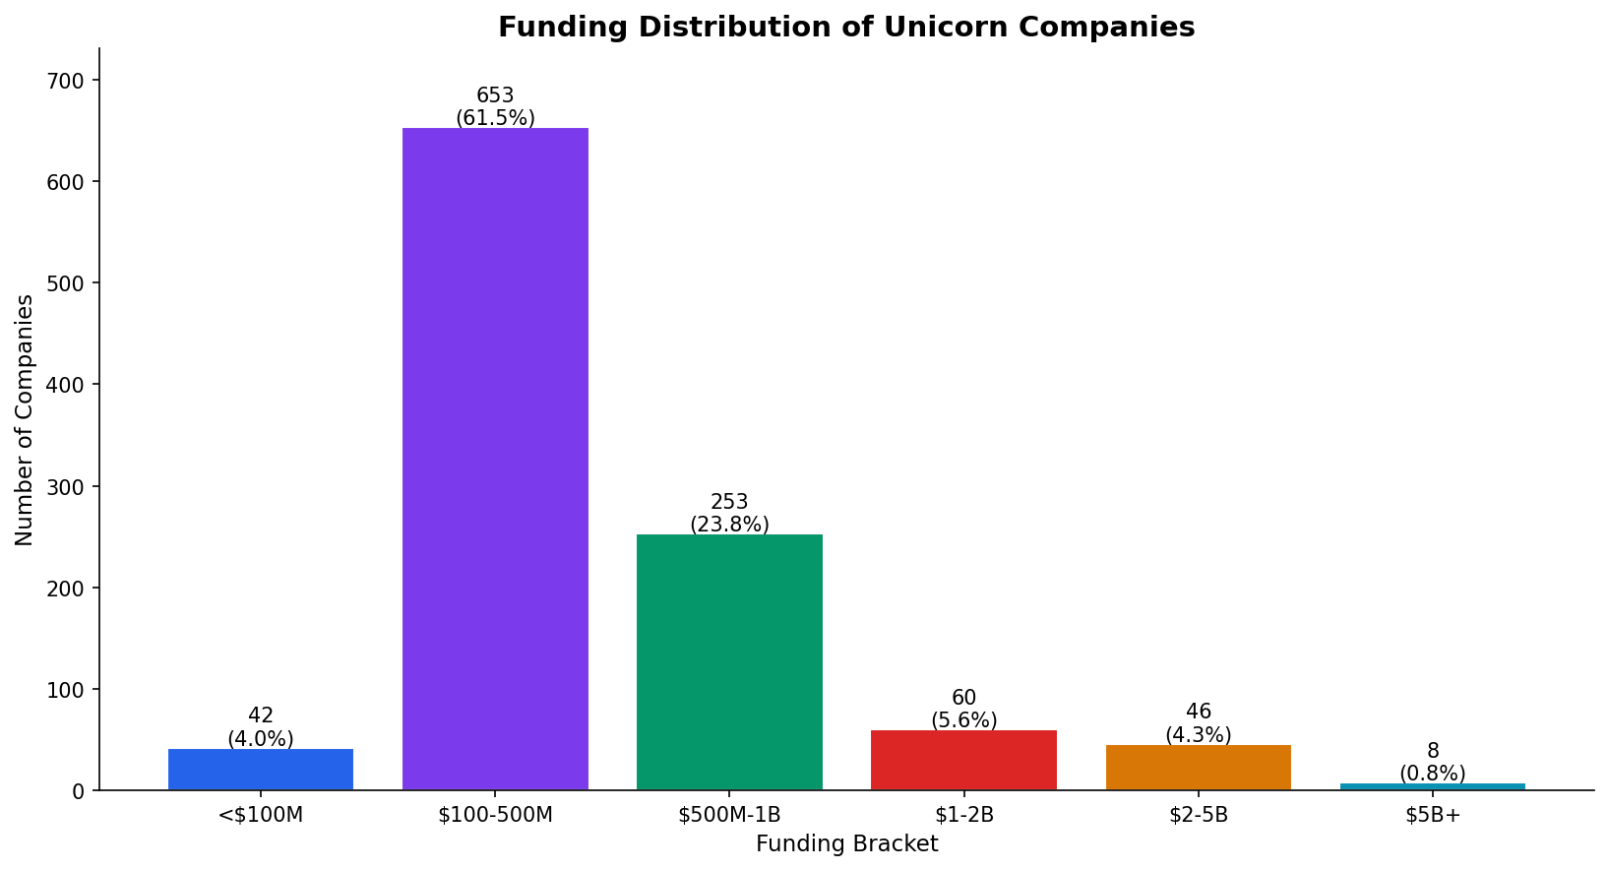
What this means — Most unicorns are "just barely" unicorns. About 84% sit in the $1B–$5B band, clustered right above the $1B threshold, while true giants are vanishingly rare. The funding side tells a complementary story: companies are valued at roughly 5x the cash they actually raised, which means the market is paying a large premium for expected future growth rather than for money already invested. Valuation is driven by narrative and growth potential, not by capital alone.

A4. Time to Unicorn
Median time from founding to unicorn status is 6 years (mean 7.0). The distribution is wide, with rare extreme outliers.
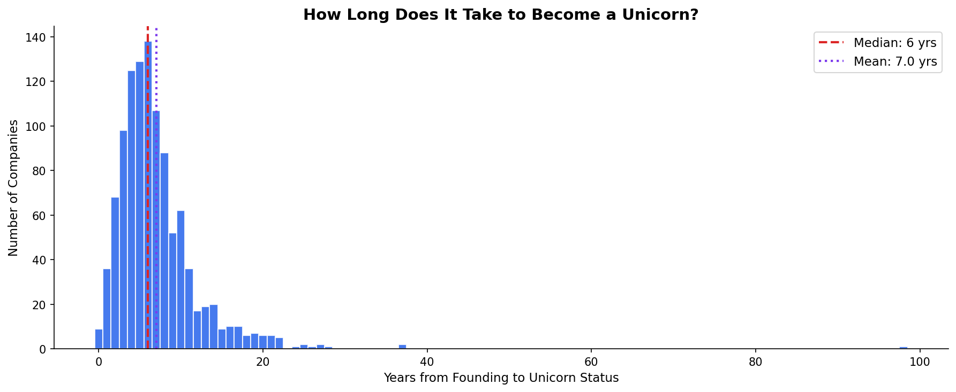
What this means — Among companies that did become unicorns, the typical one took 6–7 years to reach $1B — so this is a medium-term outcome rather than an overnight one. Important caveat: because the dataset contains unicorns only, this chart cannot be read as "taking longer raises the chance of becoming a unicorn." We have no data on the companies that never reached $1B, so any statement about the probability of becoming a unicorn would be survivorship bias. The chart describes the timing of successes, not the odds of success. The long right tail also flags a data-quality caveat: a handful of decades-old firms appear here and are not typical venture startups, which matters when this variable is used as a feature.

A5. Technological Eras (Guided Hypothesis)
Framing the data around the dominant technology wave of each period: companies are grouped by founding year into four eras. This view tests the hypothesis that each technological shift produced a distinct cohort of breakout companies.
Era | Founded | Unicorns | Dominant Wave
Dot-Com & Early Web | ≤2000 | 37 (3.4%) | First commercial internet
Web 2.0 & Social | 2001–2008 | 109 (10.1%) | Broadband + social media
Mobile & Cloud | 2009–2014 | 447 (41.6%) | Smartphones, cloud, sharing economy
AI & Modern Stack | 2015–2021 | 481 (44.8%) | AI/ML mainstream, modern fintech
- Internet Software & Services peaked in the Web 2.0 era (25.7%) and has declined since to 14.6% as the web commoditized.
- Fintech rose continuously across every era — 11.9% → 17.4% → 26.2% — becoming the single largest category in the modern stack.
- Artificial Intelligence was 0% before 2009, then appeared with the Mobile & Cloud era (8.3%) and held ~9% afterward.
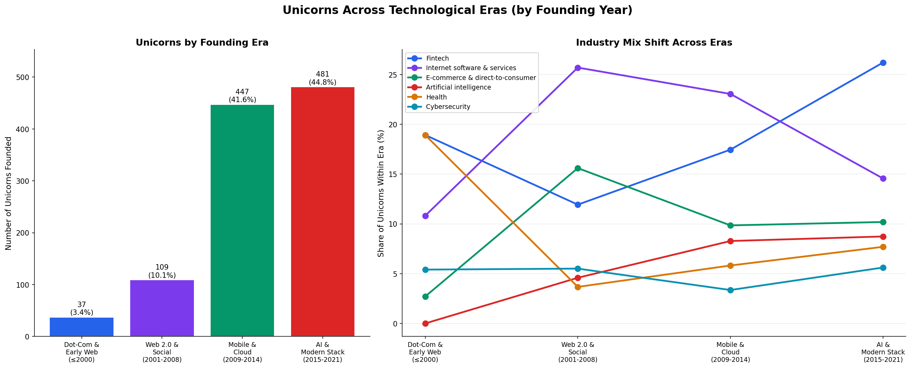
What this means — Each technology wave left a visible fingerprint on which industries produced unicorns: the Web 2.0 era was an internet-software story, while the modern stack is a Fintech-and-AI story. The data tells a clear directional narrative — old categories fade and new ones rise as the underlying technology shifts.
Statistical footnote: a chi-square test confirms the Era–Industry association is statistically significant (p = 0.0003) but weak in magnitude (Cramér’s V = 0.16). In plain terms, the industry mix genuinely shifts across eras, yet era alone explains only a small part of it — geography is a stronger structural driver (Country–Industry V = 0.25; Continent–Industry V = 0.22). Eras are defined by founding year, and because the data ends in April 2022 the most recent AI surge (e.g. post-ChatGPT) is not captured.

Section B — Independent Data-Driven Insights
This section was generated without predefined hypotheses, scanning the data (including the previously unused Select Investors field) for non-obvious patterns.

B1. Capital Efficiency Varies Sharply by Industry
Overall median valuation-to-funding multiple is 5.2x. Software-type sectors convert capital into valuation far more efficiently than asset-heavy sectors.
Most Efficient | x | Least Efficient | x
Internet Software | 6.4x | Auto & Transportation | 2.7x
Fintech | 6.2x | Travel | 2.8x
Data Mgmt & Analytics | 6.2x | Supply Chain & Logistics | 3.5x
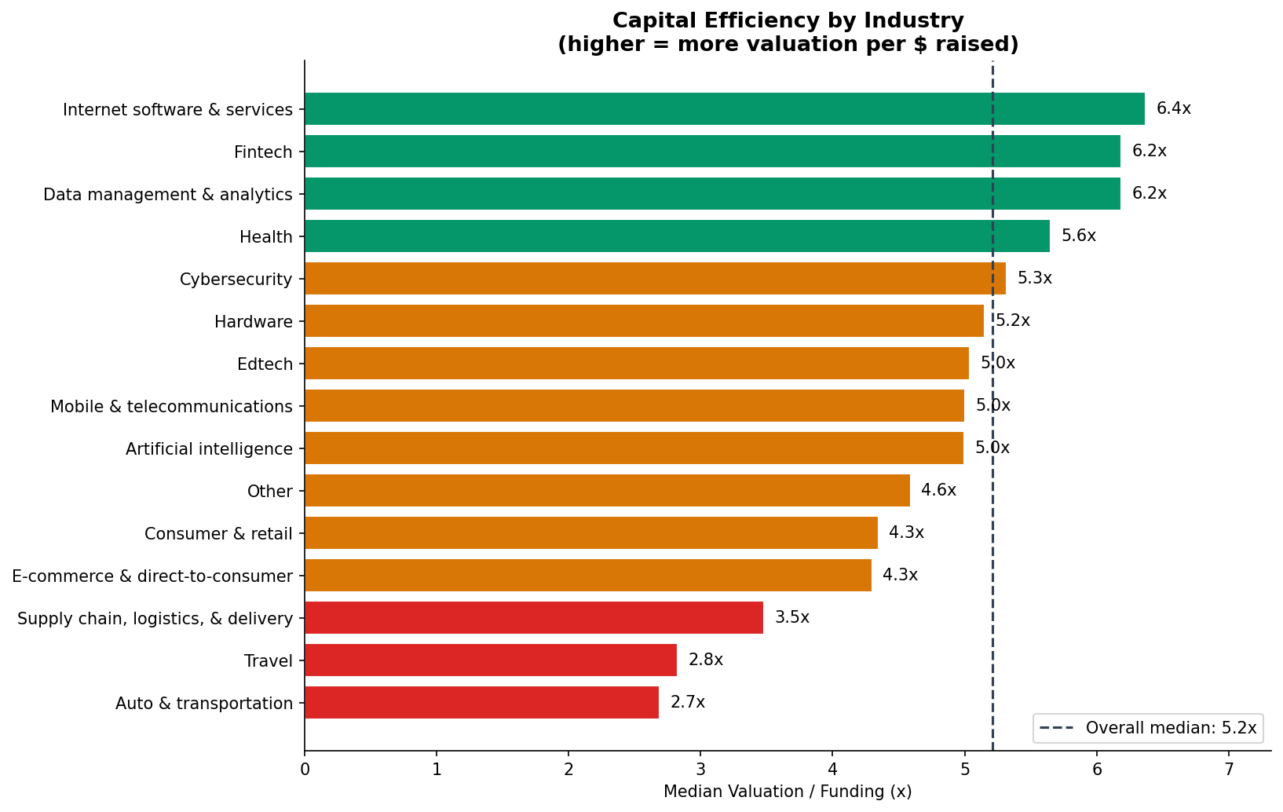
What this means — Not all unicorns are built the same way. Software sectors turn each dollar raised into more than twice the valuation of asset-heavy sectors like transportation and travel, which must keep burning cash on physical operations. This makes capital efficiency a meaningful way to separate "asset-light" from "asset-heavy" unicorns — a distinction the raw industry label alone does not capture, and a strong candidate engineered feature for clustering.

B2. A Small Set of Investors Backs a Large Share
Investor | Unicorns Backed
Accel | 60
Tiger Global Management | 53
Andreessen Horowitz | 53
Sequoia Capital China | 48
Sequoia Capital | 47
Insight Partners | 47
SoftBank Group | 34
General Catalyst | 34
Accel, Tiger Global, Andreessen Horowitz, and the Sequoia family each appear in ~50–60 unicorns — a concentrated backer network behind the population.
What this means — The same handful of elite investors recur behind a large slice of all unicorns. This suggests that who funds a company carries real signal: backing from a top-tier fund is both a vote of confidence and an accelerant (capital, network, credibility). The previously unused Select Investors field could be turned into a powerful feature — e.g. a flag for "backed by a prolific unicorn-maker."

B3. Unicorns Are a City Phenomenon, Not Just a Country One
City | Unicorns | Share
San Francisco | 152 | 14.2%
New York | 103 | 9.6%
Beijing | 63 | 5.9%
Shanghai | 44 | 4.1%
London | 34 | 3.2%
Bengaluru | 29 | 2.7%
The top 3 cities (San Francisco, New York, Beijing) alone account for 29.6% of all unicorns; San Francisco (14.2%) exceeds half of all of Europe.
What this means — Unicorns concentrate at the city level even more tightly than at the country level — they cluster in a few dense hubs where capital, talent, and founders physically collide. This means geography matters at a finer grain than "continent" or even "country"; the specific city carries information that the broader region washes out.

B4. Strong National Industry Specialization
Countries are not industry-neutral — several concentrate heavily in one sector, meaning Country and Industry are correlated rather than independent.
Country | #1 Industry | Share of Country’s Unicorns
United Kingdom | Fintech | 60%
Israel | Cybersecurity | 30%
India | E-commerce | 25%
United States | Internet Software | 27%
China | E-commerce | 17%
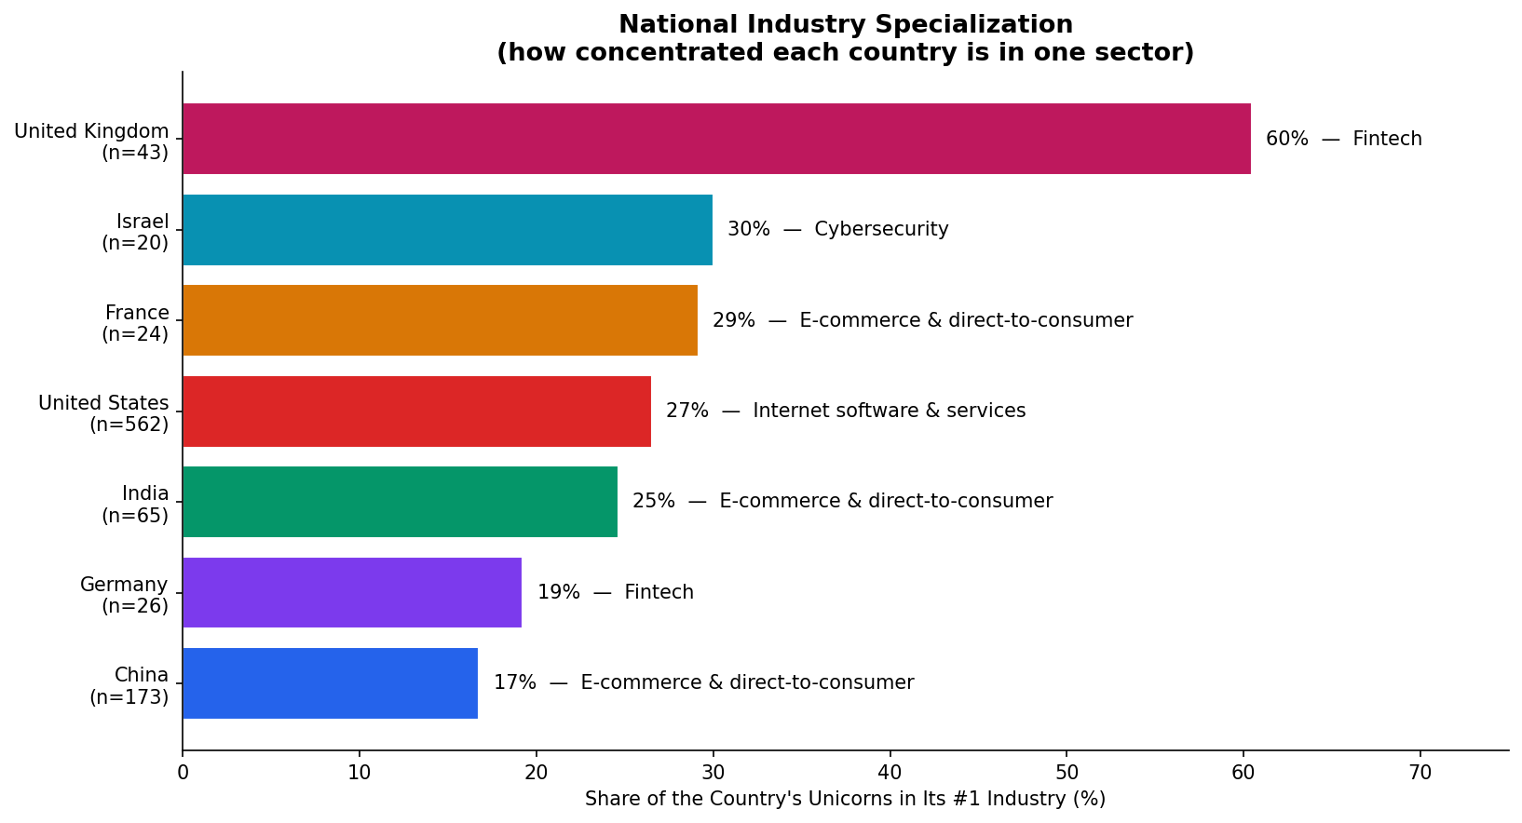
What this means — Countries are not neutral mixes of every industry — each ecosystem specializes, reflecting local strengths (UK finance, Israeli defense-born cybersecurity, India’s consumer-internet scale). The practical consequence is that Country and Industry carry overlapping information rather than independent information, so a model should not treat them as unrelated features or it will double-count the same underlying signal.

B5. Two Extremes: Instant Unicorns and Late Bloomers
- 113 companies (10.5%) reached $1B within 2 years of founding — 57 of them in 2021 alone, evidence of the capital bubble.
- 21 companies took more than 20 years; the extreme case, Otto Bock HealthCare, was founded in 1919 (98 years).
Implication: not all rows are true startups. Aged outliers contaminate the "startup" assumption and should be handled before modeling.
What this means — The population hides two very different stories at its extremes. The "instant unicorns" cluster tightly in 2021, which exposes how much the boom was a function of cheap capital and timing rather than company fundamentals alone. The "late bloomers" reveal a data-cleanliness problem: a 1919-founded firm is not a venture startup, so the dataset mixes genuine startups with re-labeled legacy companies — these outliers must be capped or filtered before any distance-based modeling.

B6. Funding and Valuation Are Only Weakly Linked
The log-log correlation between funding and valuation is only 0.60, meaning money raised explains roughly 36% of valuation variance. Counter to intuition, "more money raised" does not strongly imply "higher valuation" — sector, geography, and timing dominate.
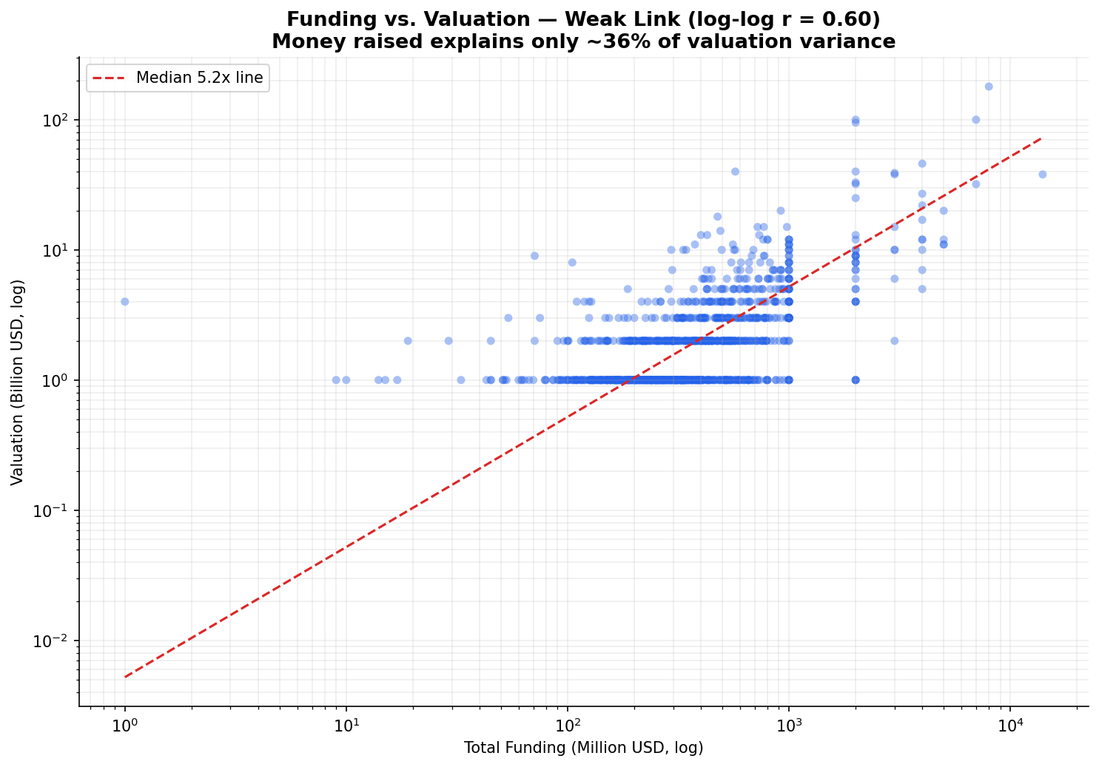
What this means — This is the most important caution for modeling. The intuitive assumption — "companies that raise more are worth more" — is only weakly true here: funding accounts for about a third of the variation in valuation, and the scatter is visibly wide. A model that leans on funding as its main predictor would miss most of the story; the remaining ~64% lives in industry, geography, timing, and investor quality. Rich, multi-dimensional features are required.

Section C — Implications for Modeling
- Coverage ends April 2022 — no data on 2023+ unicorns; recent-trend questions need a newer source.
- This dataset contains unicorns only, so it cannot by itself train a model that predicts whether a company becomes a unicorn; a labeled set with non-unicorns is required (see Data/dataset_clean.csv).
- Right-skewed Valuation/Funding and outliers in Years-to-Unicorn should be transformed or capped before distance-based methods such as K-means.
- Country and Industry are correlated (national specialization) — avoid treating them as independent.
- Capital efficiency (Valuation/Funding) is a useful engineered feature that separates asset-light from asset-heavy unicorns.
- Funding alone is a weak predictor of valuation (r ≈ 0.60); richer features are needed.

